**Testing Document Assignment 1**

**TEST 1: Testing BL, BRA, STR, LDR, MOVH, MOVLS Instructions**

**Purpose/Objective:** The purpose of this test is to input an S1 record with encoded BL, BRA, STR, LDR, MOVH, MOVLS instructions.

**Test Configuration:** The file ‘test3.asm’ will be dragged and dropped into the executable. It will contain the following S Records:

S00A00004131612E61736DB3

S10F100000010020FFFFFF8FFF7FFF70DF

S9031000EC

**Expected Results:** File ‘a1a.asm’ created with the following results:

ORG #1000

BL #1202

BRA #1004

STR.b R7,R7,#-1

LDR.b R7,#31,R7

MOVH #FF,R7

MOVLS #1F,R7  
**Actual Results:** A capture of the output (i.e., actual results) of the program.

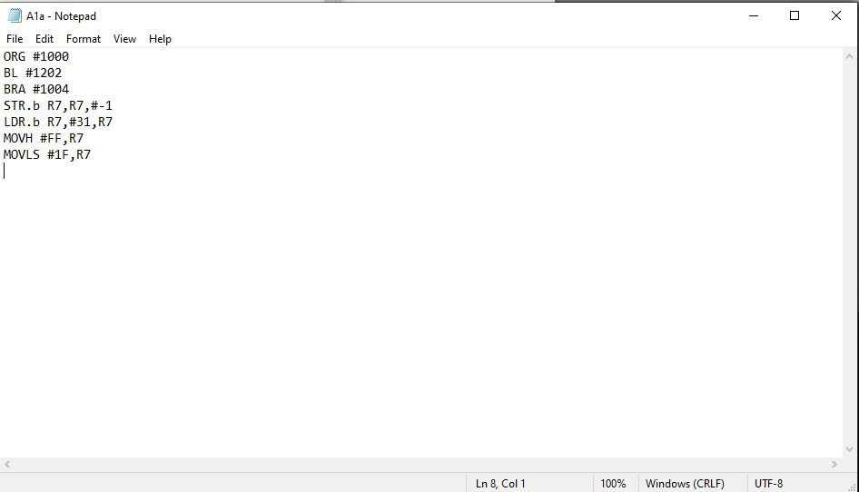

**Pass/Fail:** Pass

**TEST 2: Testing MOVLZ, MOVL, ST, LD, CEX, SETPRI Instructions with invalid ST value**

**Purpose/Objective:** The purpose of this test is to input an S1 record with encoded MOVLZ, MOVL, ST, LD, CEX, SETPRI instructions. This test will use an invalid st record.

**Test Configuration:** The file ‘test4.asm’ will be dragged and dropped into the executable. It will contain the following S Records:

S00A00004131612E61736DB3

S10F1000FF6FFF60FF5FFF58FF240128DF

S9031000EC

**Expected Results:** File ‘a1a.asm’ created with the following results:

ORG #1000

MOVLZ #FF,R7

MOVL #1F,R7

**ST.b R7,in 🡸 in indicates invalid**

LD.b R7+,R7

CEX CC,#7,#7

SETPRI #1  
**Actual Results:** A capture of the output (i.e., actual results) of the program.

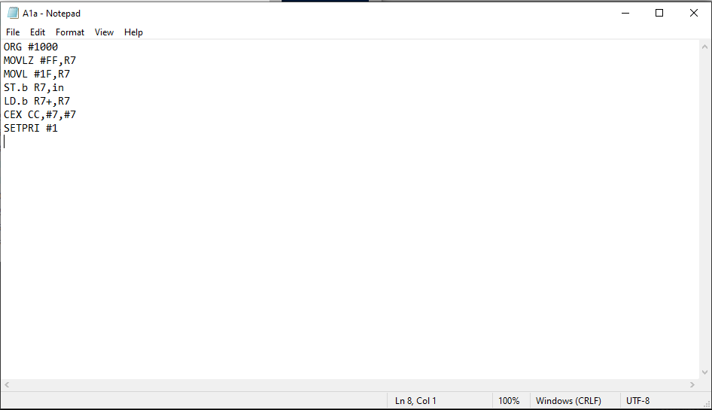

**Pass/Fail:** Pass

**TEST 2A: Testing MOVLZ, MOVL, ST, LD, CEX, SETPRI Instructions with valid values**

**Purpose/Objective:** The purpose of this test is to input an S1 record with encoded MOVLZ, MOVL, ST, LD, CEX, SETPRI instructions.

**Test Configuration:** The file ‘test4a.asm’ will be dragged and dropped into the executable. It will contain the following S Records:

S00A00004131612E61736DB3

S10F1000FF6FFF60FF5CFF58FF240128DF

S9031000EC

**Expected Results:** File ‘a1a.asm’ created with the following results:

ORG #1000

MOVLZ #FF,R7

MOVL #1F,R7

ST.b R7,R7+

LD.b R7+,R7

CEX CC,#7,#7

SETPRI #1  
**Actual Results:** A capture of the output (i.e., actual results) of the program.

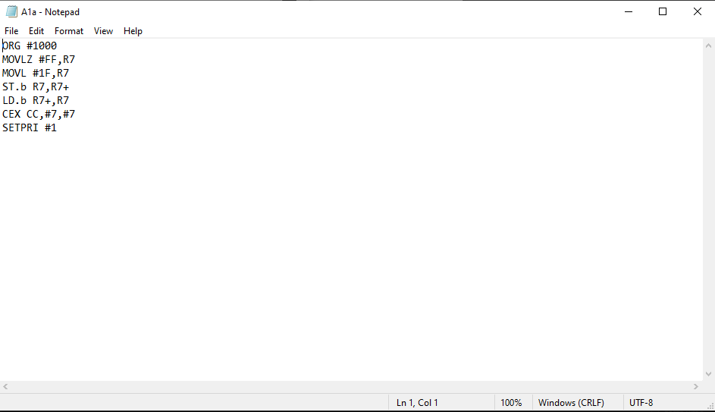

**Pass/Fail:** Pass

**TEST 3: Testing SVC, SETCC, CLRCC, ADD, ADDC, SUB Instructions**

**Purpose/Objective:** The purpose of this test is to input an S1 record with encoded SVC, SETCC, CLRCC, ADD, ADDC, SUBinstructions.

**Test Configuration:** The file ‘test5.asm’ will be dragged and dropped into the executable. It will contain the following S Records:

S00A00004131612E61736DB3

S10F1000102831284128FF40FF41FF42DF

S9031000EC

**Expected Results:** File ‘a1a.asm’ created with the following results:

ORG #1000

SVC #0

SETCC VC

CLRCC C

ADD.b #-1,R7

ADDC.b #-1,R7

SUB.b #-1,R7   
**Actual Results:** A capture of the output (i.e., actual results) of the program.

**Pass/Fail:** Pass

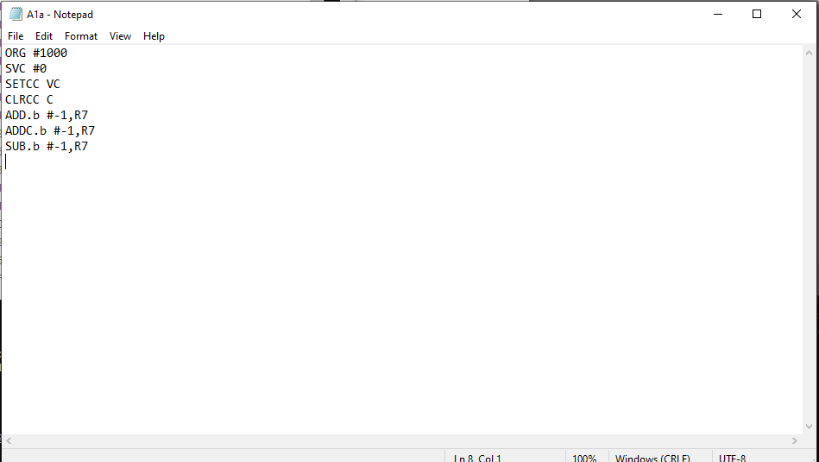

**TEST 4: Testing SUBC, DADD, CMP, XOR, AND, BIT Instructions**

**Purpose/Objective:** The purpose of this test is to input an S1 record with encoded SVC, SETCC, CLRCC, ADD, ADDC, SUBinstructions.

**Test Configuration:** The file ‘test6.asm’ will be dragged and dropped into the executable. It will contain the following S Records:

S00A00004131612E61736DB3

S10F1000FF43FF44FF45FF46FF47FF48DF

S9031000EC

**Expected Results:** File ‘a1a.asm’ created with the following results:

ORG #1000

SUBC.b #-1,R7

DADD.b #-1,R7

CMP.b #-1,R7

XOR.b #-1,R7

AND.b #-1,R7

BIT.b #-1,R7  
**Actual Results:** A capture of the output (i.e., actual results) of the program.

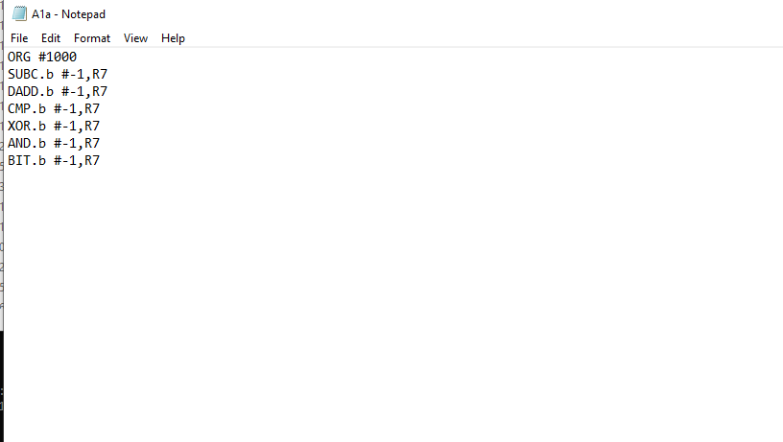

**Pass/Fail:** Pass

**TEST 5: Testing BIC, BIS, MOV, SWAP, SRA, RRC Instructions**

**Purpose/Objective:** The purpose of this test is to input an S1 record with encoded BIC, BIS, MOV, SWAP, SRA, RRCinstructions.

**Test Configuration:** The file ‘test7.asm’ will be dragged and dropped into the executable. It will contain the following S Records:

S00A00004131612E61736DB3

S10F1000FF49FF4A7F4C804C404D804DDF

S9031000EC

**Expected Results:** File ‘a1a.asm’ created with the following results:

ORG #1000

BIC.b #-1,R7

BIS.b #-1,R7

MOV.b R7,R7

SWAP R0,R0

SRA.b R0

RRC.w R0  
**Actual Results:** A capture of the output (i.e., actual results) of the program.

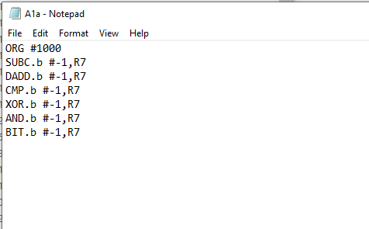

**Pass/Fail:** Pass

**TEST 6: Testing SWPB and SXT Instructions**

**Purpose/Objective:** The purpose of this test is to input an S1 record with encoded SWPB and SXT instructions.

**Test Configuration:** The file ‘test8.asm’ will be dragged and dropped into the executable. It will contain the following S Records:

S00A00004131612E61736DB3

S10F1000004E084E004E084E004E084EDF

S9031000EC

**Expected Results:** File ‘a1a.asm’ created with the following results:

ORG #1000

SWPB R0

SXT R0

SWPB R0

SXT R0

SWPB R0

SXT R0

**Actual Results:** A capture of the output (i.e., actual results) of the program.

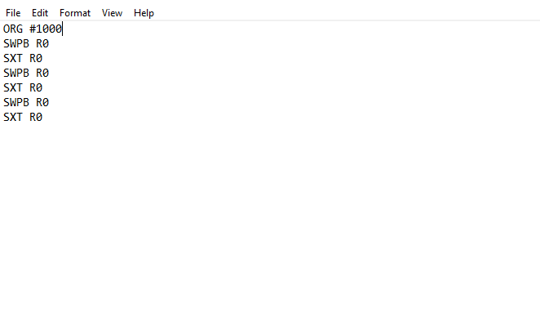

**Pass/Fail:** Pass

**Checksum tests performed as demonstrated in the Testing Document. Results were as seen in the Testing Document.**